Martini Teach and Taste Package!
At Kevin’s Martini Bar
In Pickwick & Frolic
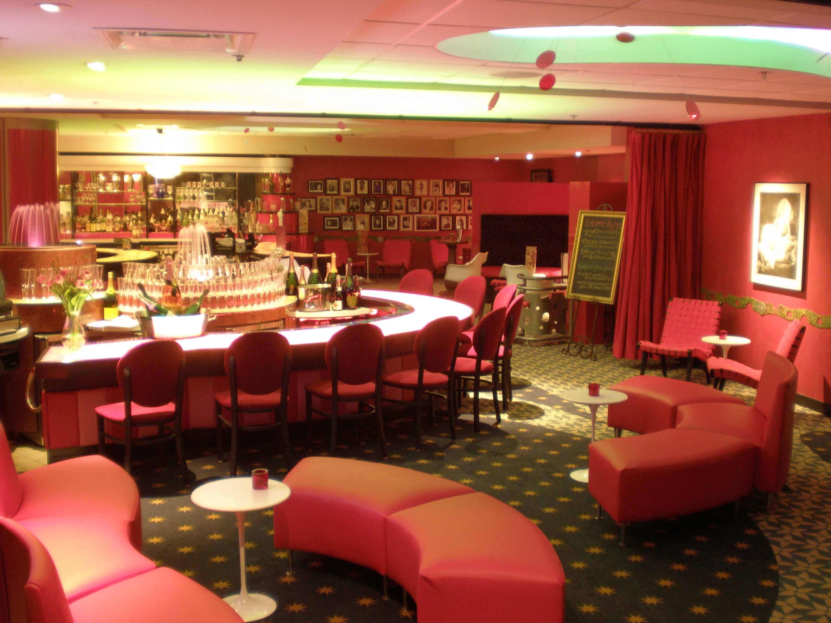

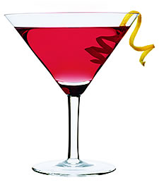

What better location to celebrate your special event or group outing than Kevin’s Martini Bar?
Choose one of our packages that covers everything, and the planning is done!

Select your choice of Martini Package and let us teach you how to make your favorites.
$25 per person
Minimum of 10 people per tasting

The Dessert-tini
Learn how to make your 3 choices and comes with a Dessert Tray:

The Tropical-tini
Learn how to make your 3 choices and comes with a Cheese and Fruit Tray:

Pickwick-tini
Learn how to make your 3 choices and comes with Fire Breads & Spreads Tray:

Each Package Includes:
A welcome sign for the group
A how-to lesson for the 3 martini tastes of your choice
Recipe cards for each martini to take home
Reserved space in the Martini Bar or Champagne Bar prior to 8:00*

*If group is arriving after 8:00, the bartender will be informed and will try to hold any open space available shortly prior to arrival. All Three Martinis must be from one group only.

All packages are subject to tax and gratuity

Martini Teach and Taste Choices

The Dessert-tini
Key Lime Martini
French Silk Lemon Meringue
Chocolate Covered Cherry
Classic Chocolate
Raspberry Truffle

The Tropical-tini
Orange Bliss
Pineapple Upside-Down Cake
Rain Forest
Citrus Drop
4th Street Limbo

Pickwick-tini
Grape Freeze
Raspberry Sparkler
Jeremiah Weed
Hazelnut Espresso
Eros

Custom packages are available upon request
and may incur an additional fee per person based on request.

