the tasting hour
A unique concept that allows our guests to try existing menu items, including beer/wine, in tasting portions and tasting prices, as well as appetizers in full portions at tasting prices. Also, each month we have chosen themes and brought in new products that will coordinate with the month’s featured theme…

apps
Basil Marinara Pizza- $6
American Bistro Pizza- $9
Margherita Pizza- $8
Fire Breads & Spreads- $7
Butternut Squash Croustade- $6
Mussels- $8
Calamari- $7
French Fries- $5

beer
2 ounce taste = $1
$2 off Craft Beer Selections
Please See Our Current Draft List for Tasting Selections

wine 3o z./ 6oz ./ bottle
RED
Reguenos Red Blend 2 / 4 / 16
The Velvet Devil Merlot 2.75 / 5.50 / 22
Guenoc Red Blend 2.75 / 5.50 / 22

WHITE & SPARKLING
Avanti -Pinot Grigio 2.50 / 5 / 20
High Def-Reisling 3 / 6 / 24
Biutiful NV Cava Rose 3 / 6 / 24

booze
$3 off all specialty cocktails and martinis printed on Pickwick & Frolic’s drink menu

june:patio

beer:
Sierra Nevada Ruthless Rye IPA
Brewed with rustic grains combining the peppery spice of rye & the bright citrus flavor of whole-cone hopes.

wine:
Domaine De Montrabech – Grenache Blanc
2.50 / 5 / 20
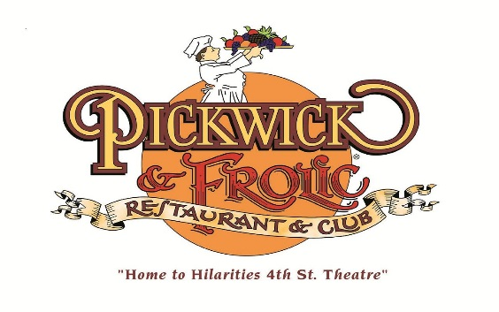
Available 3pm -6pm Tuesday-Friday & Sunday

june- patio

july- independence

august- spice

september- brand new

october- harvest

november- family occasions

december- holiday

